2022 Issue 01
Bourne End Junior Sports Club
Covid 19 – Operating safely guidelines
HALL USERS VERSION
Matthew Todd
Sports hall, new road, bourne end, bucks, SL8 5BS

Covid-19 Risk Assessment & Safeguarding of Staff, Volunteers, Visitors & Members

Definitions

Charity | Means Bourne End Junior Sports Club (BEJSC), a registered charity.
C19 | Means the Covid 19 Coronavirus.
Responsible Person | Means Matthew Todd.
Register of Systems | Means a register of all systems or contexts in which personal data is processed by the Charity.

Purpose

The purpose of this document is to provide information and guidance for all users of the sports hall and for the Trustees of Bourne End Junior Sports Club in connection with the steps and actions being taken during the lockdown period and in order to re-open the club safely.

This document effectively follows the government guidance issued as at 01/06/2020 and updated 22/09/2020 can be found at:

- https://www.gov.uk/government/publications/coronavirus-covid-19-guidance-on-phased-return-of-sport-and-recreation/guidance-for-providers-of-outdoor-facilities-on-the-phased-return-of-sport-and-recreation;
- https://www.gov.uk/government/publications/coronavirus-covid-19-meeting-with-others-safely-social-distancing/coronavirus-covid-19-meeting-with-others-safely-social-distancing?fbclid=IwAR3RXnyBdhJI6E8wEbG7p0MkIkeaa6aIMWiF5JD_hpaN7a9IvR92XOuKSuw

- https://www.gov.uk/guidance/working-safely-during-coronavirus-covid-19/providers-of-grassroots-sport-and-gym-leisure-facilities

- https://www.gov.uk/guidance/working-safely-during-coronavirus-covid-19/offices-and-contact-centres

Sports Hall Users
We need to put in place procedures to protect hall users and to protect the hall from users.
Entering and leaving the building
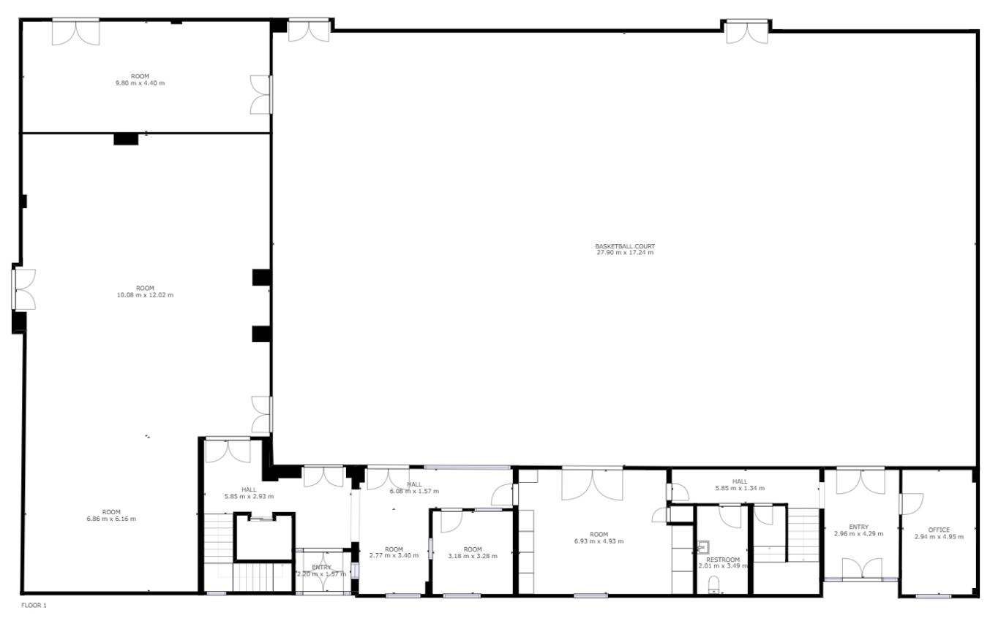

1
Exit
Entry

- Hall users should enter the building via the left hand side doors, marked Entry
- Hall users should EXIT the building via the right hand side doors, marked Exit
- If you must wait in the area marked 1 then we request that face coverings are worn at all times
- There are hand washing and drying facilities in the downstairs toilet facility
- We also request the use of the hand sanitiser, located at the entrance, when entering the building

Indoor Areas (inc 1st Floor Facilities)
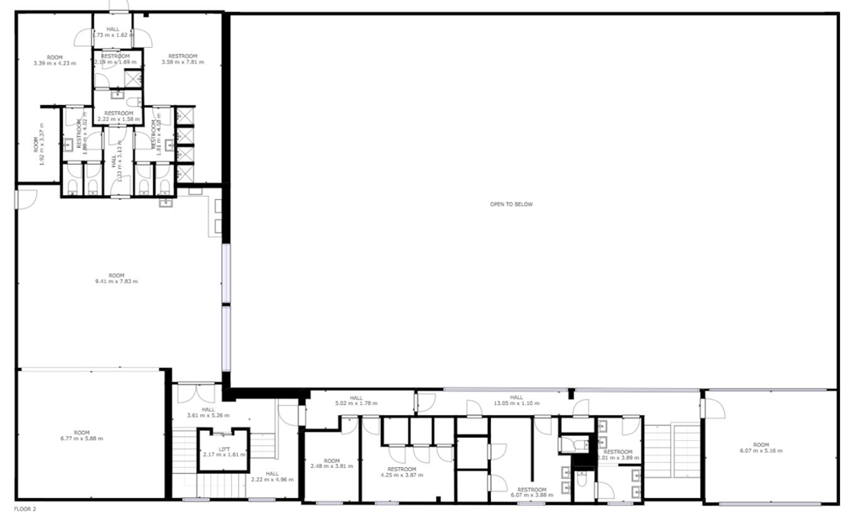
Use of Lobby Area
If people or parents/guardians are congregating in the lobby area and the number of people exceeds 6, we ask that you politely request them to wait outside or in their vehicles.
Whilst in the lobby area, we require the wearing of face coverings.
Use of Main Hall
Sporting Activities
Each section leader or hall hirer (3rd party or E-Act Academy) must take the relevant steps to carry out sport specific restrictions as advised by the sports governing bodies.
As at the 22/09/2020 the guidance relevant to the use of the hall is as follows: -

- Limits on the number of people you can see socially have changed. When meeting friends and family you do not live with (or have formed a support bubble with) you must not meet in a group of more than 6, indoors or outdoors. This is against the law and the police will have the powers to enforce these legal limits, including to issue fines (fixed penalty notices) of £200, doubling for further breaches up to a maximum of £6,400.
There are exceptions where groups can be larger than 6 people. These include:
- for work, or the provision of voluntary or charitable services
- registered childcare, education or training
- supervised activities provided for children, including wraparound care, youth groups and activities, and children’s playgroups
- elite sporting competition and training
- exercise classes, organised outdoor sport or licensed outdoor physical activity, and supervised sporting activity (indoors or outdoors) for under-18s
- indoor organised team sports for disabled people
Where a group includes someone covered by such an exception (for example, someone who is working), they are not counted as part of the gatherings limit. This means, for example, a tradesperson can go into a household of six without breaching the limit, if they are there for work.
The guidance advises a minimum of 100sq feet per person for an indoor activity. The main hall measures 5160sq feet. We are limiting the number of users in the hall to 30 (U18’s sessions only). Adults must remain under the rule of 6 whilst engaging in sport in the hall.
Please follow the guidance on the posters around the hall and as shown in this document.
To comply with these steps section leaders and sports hall hirers are required to carry out the following:
- At the start and end of each session the door handles and edges of doors to be cleaned with sanitising wipes.
- All equipment such as badminton posts, goal posts, table tennis tables must be cleaned at the start once put in position, and at the end once replaced in the storeroom after each session
- Guidance from Governing Bodies of sports must be adhered to at all times and these are included in the attached Appendices 1 to 7
- Recommendation is for small groups to participate in training separated from each other and other small groups to at least 2 metres
- No competitive sports should be played where close frequent or prolonged physical contact is likely to occur
- Wherever practicable open external doors to increase ventilation – BUT ENSURE they are closed properly and wiped down after use
- MAINTAIN A RECORD OF USERS WITH CONTACT NUMBERS
All cleansing wipes must be placed in bins provided and participants should clean their hands with gel provided.
Use of John Clinton Room
At the start and end of each session the door handles and edges of doors to be cleaned with sanitising wipes.
- Distancing rules must be applied when using this space for both personal or group training purposes
- Distancing rules must be applied when using this space for meetings
- Exercise sessions must comply with latest guidance of appropriate distance between participants
- All exercise mats must be cleaned before & after each use
- All door or chair handles and tables must be cleaned before and after use.
All cleansing wipes must be placed in bins provided and participants should clean their hands with gel provided.
Use of Kitchens
- Kitchen areas are to remain closed for the foreseeable future and cannot be used for food or drinks preparation.
Use of Toilets & Showers
- Both male & female shower areas on the first floor will be closed for the foreseeable future as shown in picture above by
- Both male & female toilet facilities on the first floor will be closed for the foreseeable future as shown in picture above by.
The disabled, general use & baby changing toilet facility on the ground floor will remain accessible and cleaning regimes will be increased by the building manager / caretaker throughout the day. This area is marked on the plan by a .

COVID-19 Contamination
In the event of a confirmed or suspected case of a staff member, volunteer, club member, visitor or hirer the following procedures must be followed: -
- The hall, facilities and all contact points such as handles, handrails and the like must be cleaned with a normal household disinfectant as this will reduce the risk of passing the infection on to other people
- This deep clean should be undertaken using gloves, masks and aprons, which should be double bagged and stored securely for 72 hours before being disposed of as per the waste rules below
Waste
Waste from litter bins and cleaning of areas (including disposable cloths and tissues):
- Should be put in a plastic rubbish bag and tied when full.
- The plastic bag should then be placed in a second bin bag and tied.
- Waste should be kept away / locked away from children
- It should be put in a suitable and secure place and marked for disposal

Appendix 1 – BEJSC Hall Poster

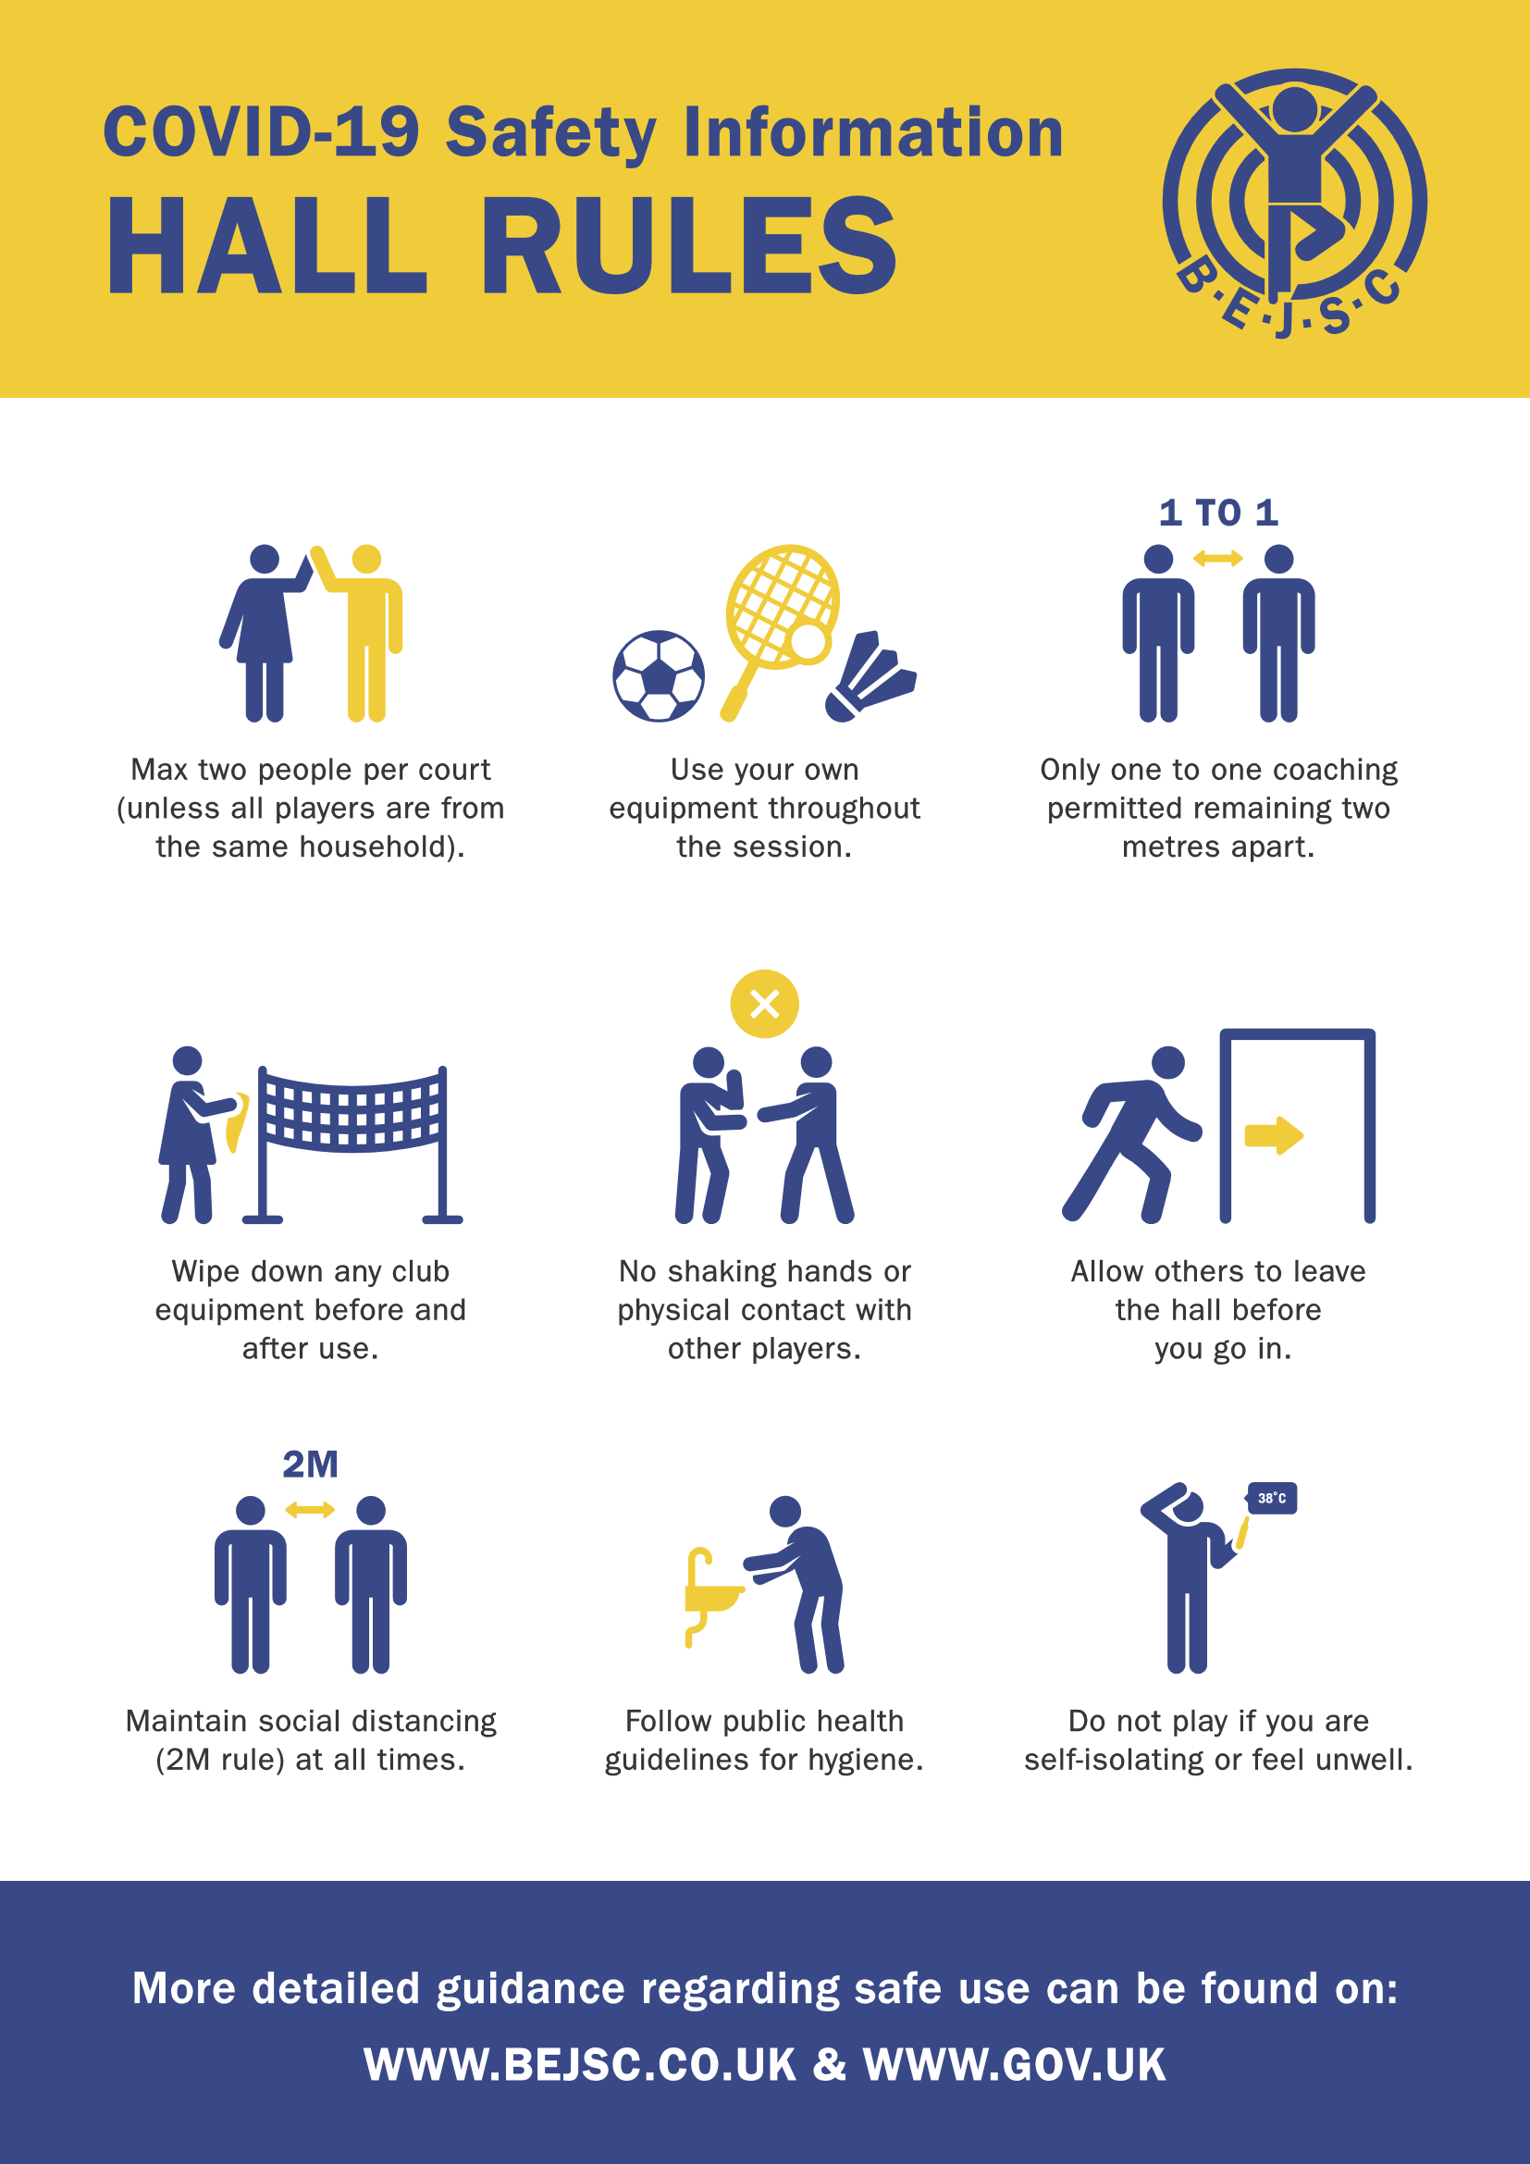

Appendix 9 – Risk Assessment

Risk assessment template - Coronavirus

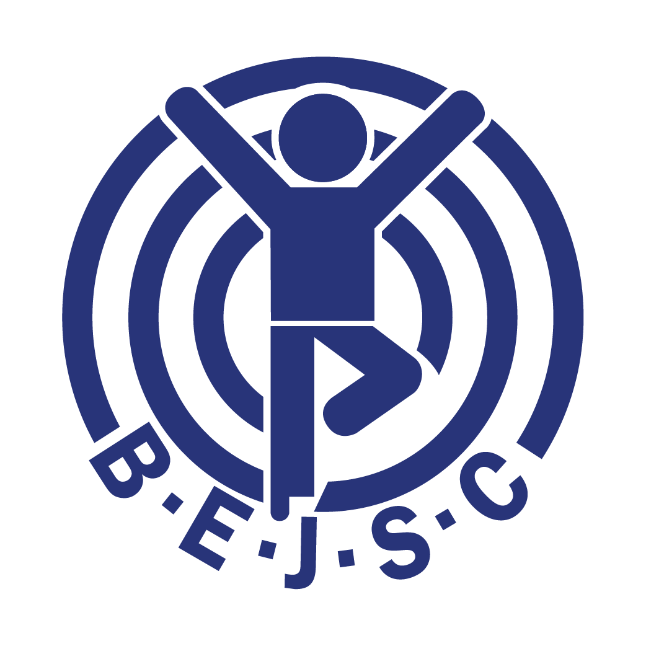

Company name: BEJSC (Bourne End Junior Sports Club) Assessment carried out by: Matthew Todd

Date of next review: 01/11/2020 Date assessment was carried out: 21/08/2020

What are the hazards? | Who might be harmed and how? | What are you already doing to control the risks? | What further action do you need to take to control the risks? | Who needs to carry out the action? | When is the action needed by? | Done
Contact with others | Members, leaders, coaches, helpers, visitors, staff | Referring to sporting bodies for each section | 1. Provide information posters and advice  2. Provide sanitising station(s)  3. One way system for entry and exit | All | 08/06/2020 | 08/06/2020
Contamination of Sports Equipment | Members, leaders, coaches, helpers, staff | Restricting use of equipment | 1. Ensure participants use only their own equipment  2. Equipment is cleaned after each use | Members, leaders, coaches, helpers | 08/06/2020 | 08/06/2020
Waste | Members, leaders, coaches, helpers, visitors, staff | Separate bins for general waste and cleansing wipes and cleaning products | Daily emptying of cleansing wipes bins & remote storage until collection | Hall Manager | 08/06/2020 | 15/06/2020
Drop Off / Collection of members | Members, leaders, coaches, helpers, visitors, staff | Reduce access by encouraging parents / users to only access the hall if using the facility | Restrict waiting in entrance / lobby area to 10 minutes. Use a one-way system for entry and exit | All hall users, parents and carers | 25/07/2020
Use of Kitchen Facilities | Members, leaders, coaches, helpers, visitors, staff | Close kitchen areas | None, ensure kitchen area cleaning is maintained | Hall Manager | 25/07/2020 | 21/07/2020
Facilities | Members, leaders, coaches, helpers, visitors, staff | Close shower rooms, upstairs toilets | Maintain access to downstairs toilet, disabled and baby changing facilities and increase cleaning frequency to between 2 and 3 times a day depending on hall usage | Hall Manager | 25/07/2020 | 21/07/2020
Ventilation | Members, leaders, coaches, helpers, visitors, staff | Advising users to open external doors | Provide wedges to prop non fire doors open to minimise contact and increase ventilation | Members, leaders, coaches, helpers | 01/09/2020 | 22/09/2020

